# Looking

# PowerApp installation instructions

All the files and the instructions can be found at <https://aka.ms/betterreporting>

## Install the PowerApp

From the PowerApps app, go to **Apps** -> **Import Canvas App**

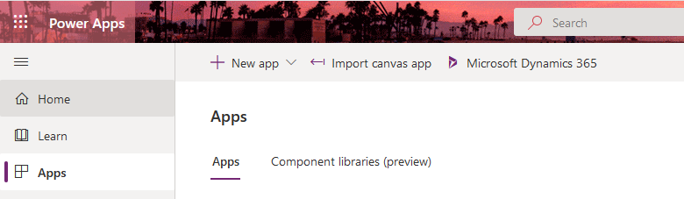

Select **Upload**

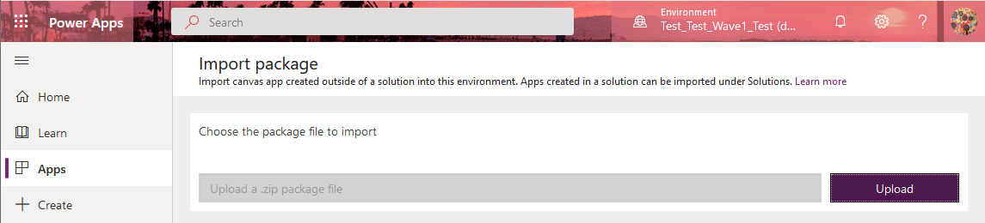

Navigate to the PowerApp .zip file and click OK.

From the Import Package screen select **Update**

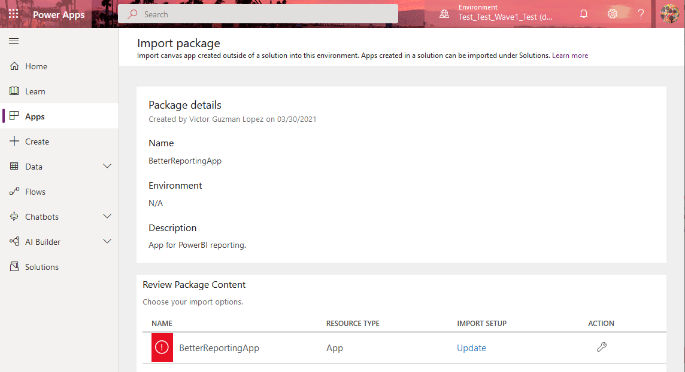

Hit the dropdown and select **Create as New** and Select **Save**

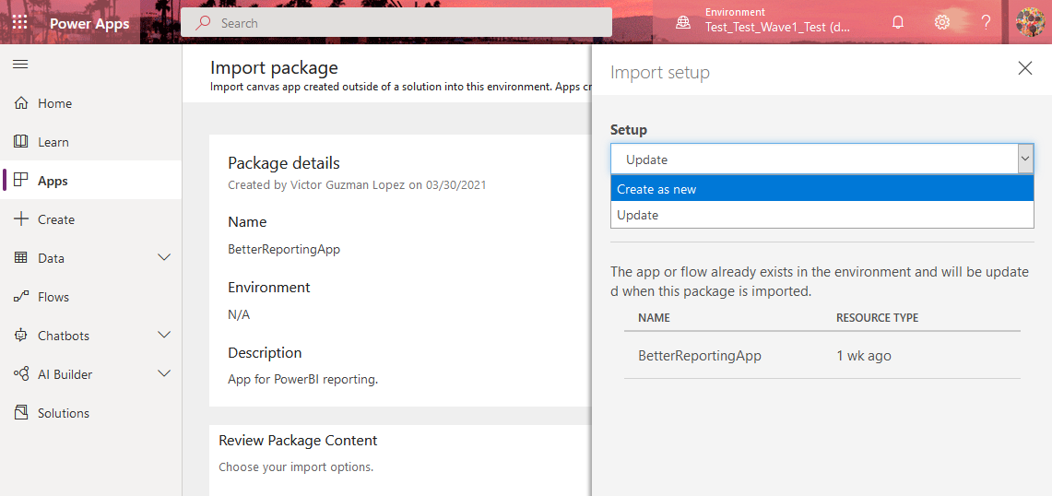

For the final action, click **Import**

Once the app has been imported successfully, we need to determine the App ID. Go to **Apps**. From the … menu, select **Details.**

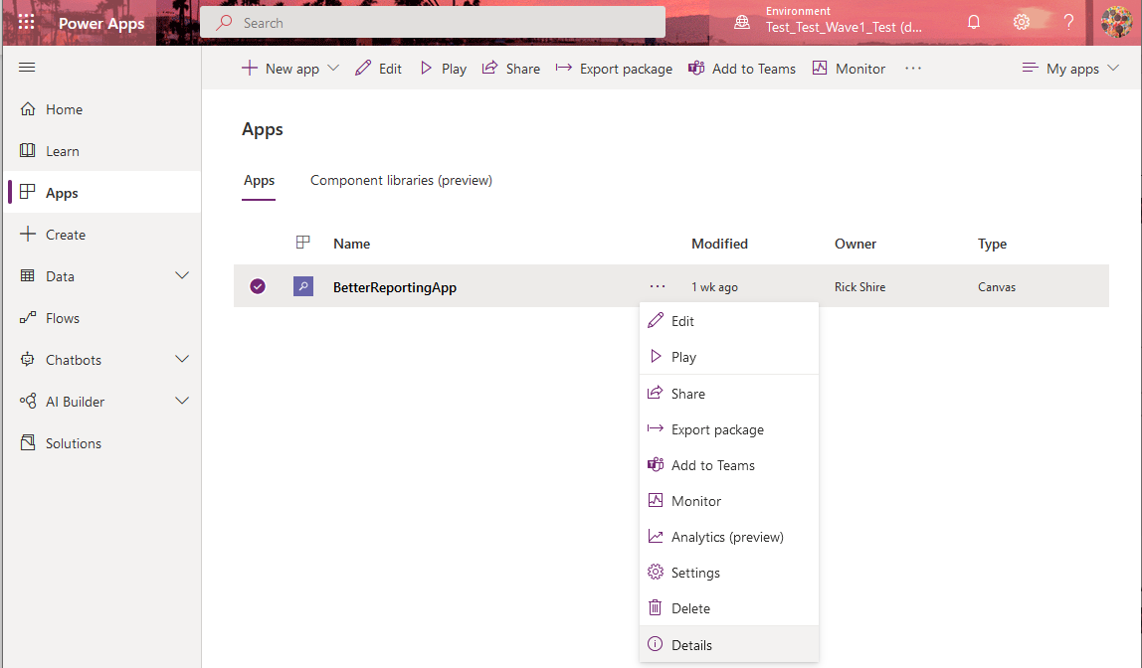

Copy the App ID and save it for later. We will need this for a future step.

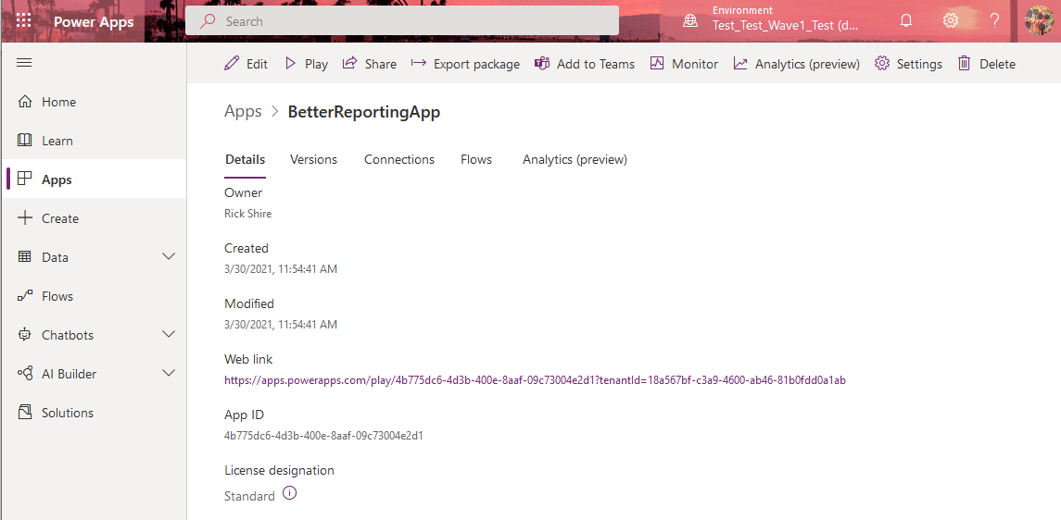

## Share the PowerApp to any user that will consume the PowerBI reports.

Highlight the PowerApp

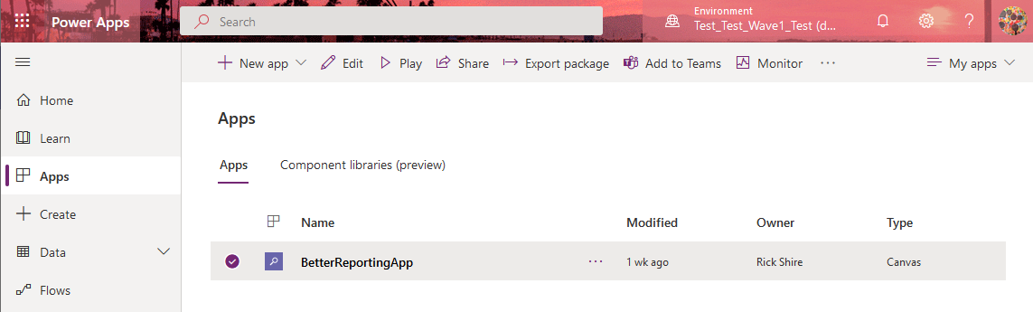

From the sharing dialog, add the users that require access (or select Everyone), and click **Share.** I would recommend that you uncheck **Send an email invitation to new users beforehand.**

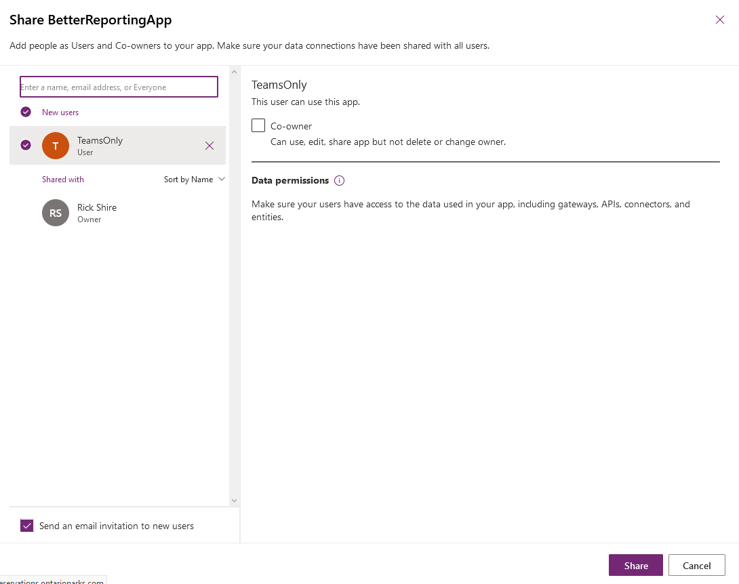

## Remove the PowerApp from the PowerBI template

You will find a placeholder PowerApp in the PowerBI template on two report tabs. The PowerApp placeholder will generate an error message similar to this.

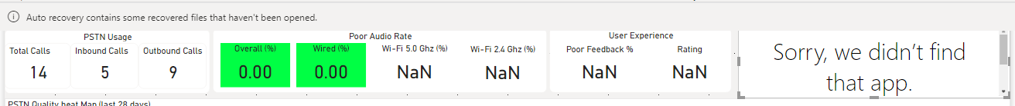

This is to be expected. The reason for the error, is that the PowerApp was added to the template using a PowerApp App ID from another tenant. To resolve this, we need to re-add the PowerApp to the reports and reconfigure the template.

First, remove the PowerApp from the PowerBI template. There are two instances of the app. Do this step twice, once for each instance. To accomplish this, select the PowerApp, and then select **Cut** from the menu.

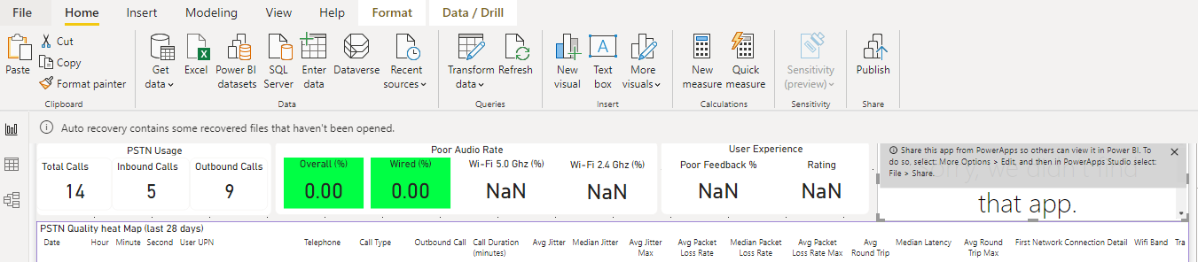

## Add the PowerApp back to the PowerBI template

Got to the **Insert** menu, then select **PowerApps**

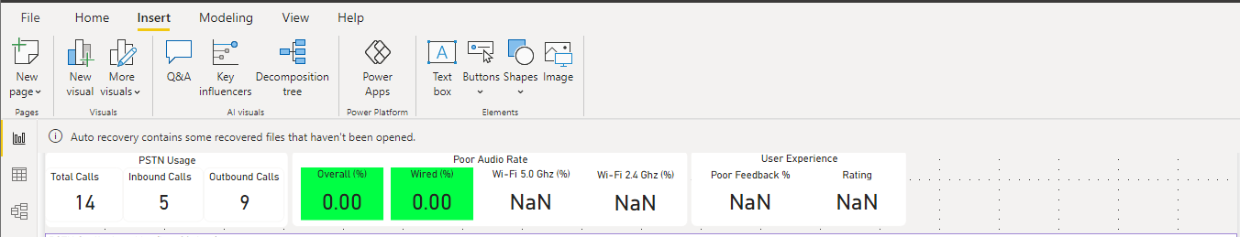

Add the following fields to the PowerApp visualization.

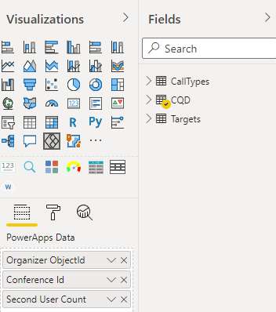

From the PowerApp visual, select **Choose App**

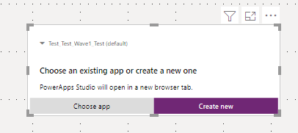

Select the BetterReportingApp, and click **Add**

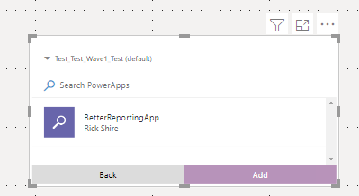

Select **Skip,** and move the PowerApp visualization into place.

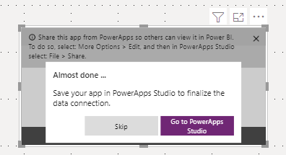

Select the table visualization. Once selected, click on the **Format** menu, then select **Edit Interactions**. Select the Filter option in the PowerApp visualization. The Filter option looks like a bar chart (see highlighted section in red). The select **Edit Interactions** again to exit that mode.

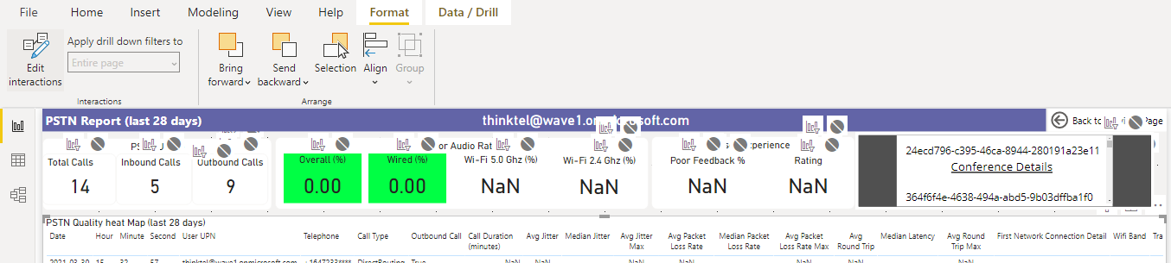

Once this is complete, you can copy and paste the PowerApp visualization from this report tab, to the other report tab. Move and resize accordingly.